

Semester One Examination, 2013

SOLUTIONS

MATHEMATICS SPECIALIST 3A

Section One:

Calculator-free

Student’s name SOLUTIONS

Teacher : Mr White

Time allowed for this section
Reading time before commencing work: five minutes
Working time for this section: fifty minutes

Materials required/recommended for this section

To be provided by the supervisor
This Question/Answer Booklet
Formula Sheet

To be provided by the candidate
Standard items: pens, pencils, pencil sharpener, eraser, correction fluid/tape, ruler, highlighters

Special items: nil

Important note to candidates

No other items may be used in this section of the examination. It is your responsibility to ensure that you do not have any unauthorised notes or other items of a non-personal nature in the examination room. If you have any unauthorised material with you, hand it to the supervisor before reading any further.

Structure of this paper

Section | Number of questions available | Number of questions to be answered | Working time (minutes) | Marks available | Percentage of exam
Section One:  Calculator-free | 6 | 6 | 50 | 50 | 33
Section Two:  Calculator-assumed | 12 | 12 | 100 | 100 | 67
 |  |  | Total | 150 | 100

Instructions to candidates

- The rules for the conduct of Western Australian external examinations are detailed in the Year 12 Information Handbook 2013. Sitting this examination implies that you agree to abide by these rules.

- Write your answers in the spaces provided in this Question/Answer Booklet. Spare pages are included at the end of this booklet. They can be used for planning your responses and/or as additional space if required to continue an answer.
- Planning: If you use the spare pages for planning, indicate this clearly at the top of the page.
- Continuing an answer: If you need to use the space to continue an answer, indicate in the original answer space where the answer is continued, i.e. give the page number. Fill in the number of the question(s) that you are continuing to answer at the top of the page.

- Show all your working clearly. Your working should be in sufficient detail to allow your answers to be checked readily and for marks to be awarded for reasoning. Incorrect answers given without supporting reasoning cannot be allocated any marks. For any question or part question worth more than two marks, valid working or justification is required to receive full marks. If you repeat an answer to any question, ensure that you cancel the answer you do not wish to have marked.

- It is recommended that you do not use pencil, except in diagrams.

Section One: Calculator-free (50 Marks)
This section has six (6) questions. Answer all questions. Write your answers in the spaces provided.

Working time for this section is 50 minutes.

Question 1 (3 marks)
(a) Write 9° in radians. (1 mark)

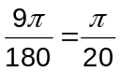

(b) Add the angles , and , giving your answer in degrees. (2 marks)
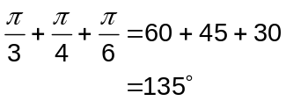

Question 2 (9 marks)
(a) Complete the table for 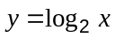. (2 marks)

 |  |  | 1 | 2 | 4
 | -2 | -1 | 0 | 1 | 2

(b) Draw the graph of . (2 marks)
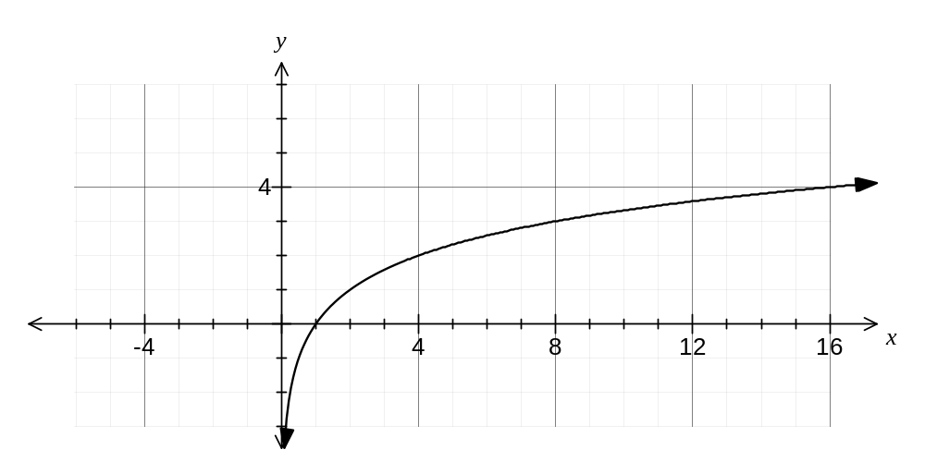

(c) (5 marks)

A flagpole stands vertically on level ground . When the sun’s elevation is 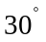,
the flagpole casts a shadow length of 30 metres. Find the exact height of the flagpole.

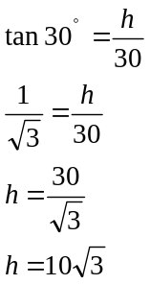
Question 3 (9 marks)
(a) Given that 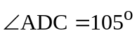 find the exact value of DC in the diagram below. (6)
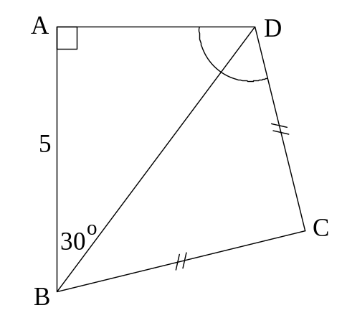
and as 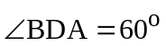
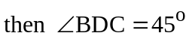
cos 30º = 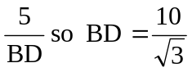
Pythagoras : 2DC² = BD²
DC² =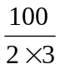
DC =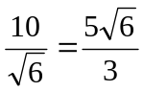

(b) Determine the exact area of an equilateral triangle of side length of 5 metres (3)
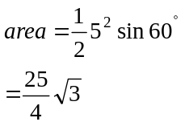

Question 4 (10 marks)
(a) Simplify:

(i) 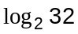 (1 mark)
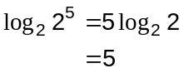

(ii) 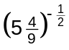 (2 marks)
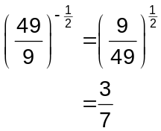

(b) If 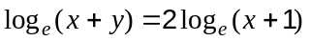, express in terms of . (2 marks)
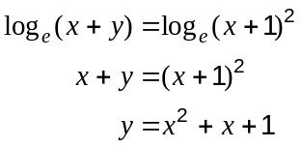

(c) Solve for :

(i) 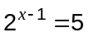 (2 marks)
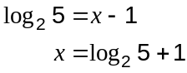 or 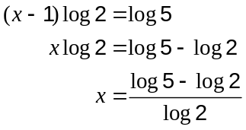

(ii) 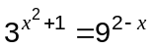 (3 marks)
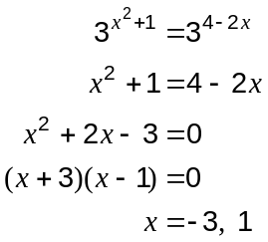

Question 5 (9 marks)
Let 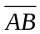 represent a chord in a circle of centre, O, and radius 3 cm. The angle subtended by this chord at the centre is 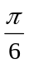 (i.e. 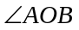).

Determine the following.

(a) The exact length of the chord, (simplified). (5)

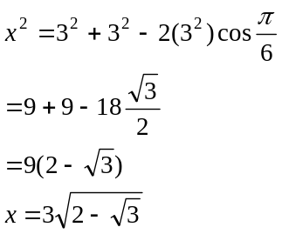

(b) The exact area of the minor segment formed above. (4)

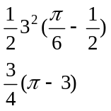
Question 6 (10 marks)
The graph of 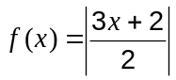 is shown below.
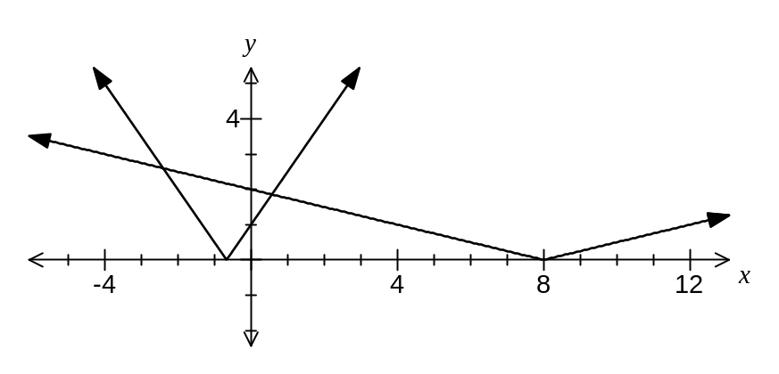
(a) Determine 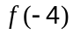. (1 mark)
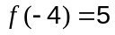

(b) Sketch the graph of 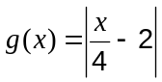 on the axis above. (2 marks)

(c) Solve 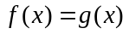. (4 marks)
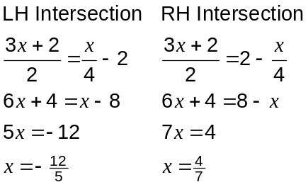

(d) Solve 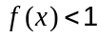. (3 marks)
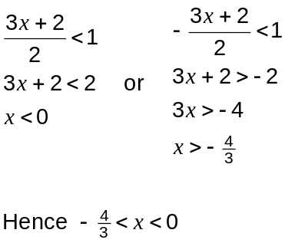

Additional working space

Question number: _________

Additional working space

Question number: _________

Additional working space

Question number: _________

This examination paper may be freely copied, or communicated on an intranet, for non-commercial purposes within educational institutes that have purchased the paper from WA Examination Papers provided that WA Examination Papers is acknowledged as the copyright owner. Teachers within purchasing schools may change the paper provided that WA Examination Paper's moral rights are not infringed.

Copying or communication for any other purposes can only be done within the terms of the Copyright Act or with prior written permission of WA Examination papers.

Published by WA Examination Papers
PO Box 445 Claremont WA 6910

